SOFTWARE

REQUIREMENTS SPECIFICATION

For

Airline Reservation System

Prepared by:
Naresh.R
Nirmal.R
Prasaanth.K.Y
1. Introduction
1.1 Purpose

The main objective of this document is to illustrate the requirements of the project Airline Reservation System. The document gives the detailed description of the both functional and non-functional requirements proposed by the client. The purpose of this project is to provide a friendly environment to maintain the details of passenger and flights. The main purpose of this project is to wase o This project describes the hardware and software interface requirements using ER diagrams and UML diagrams.

1.2 Document Conventions
- Convention for Main title
- Font face: Times New Roman
- Font style: Bold
- Font Size: 14

- Convention for Sub title
- Font face: Times new Roman
- Font style: Bold
- Font Size: 12
- Convention for body
- Font face: Times New Roman
- Font Size: 12

1.3 Scope of Development Project

Airline Reservation System is an internet-based application that enable users book , view ticket and track flights.

The project is specifically designed for the use of airline passengers and attendant verification. This application will work as a complete user interface for online ticket booking and management. It is majorly focused on the department of airline’s online ticket booking .

The language used for developing the project is Java as it is quite advantageous than other languages in terms of performance, tools available, cross platform compatibility, libraries, cost (freely available), and development process.

1.4 Definitions, Acronyms and Abbreviations
JAVA -> platform independence

SQL-> Structured query Language
ER-> Entity Relationship

1.5 References

  - Websites

http://www.slideshare.net/

https:// www.emirates.com/
- Overall Descriptions
2.1 Product Function

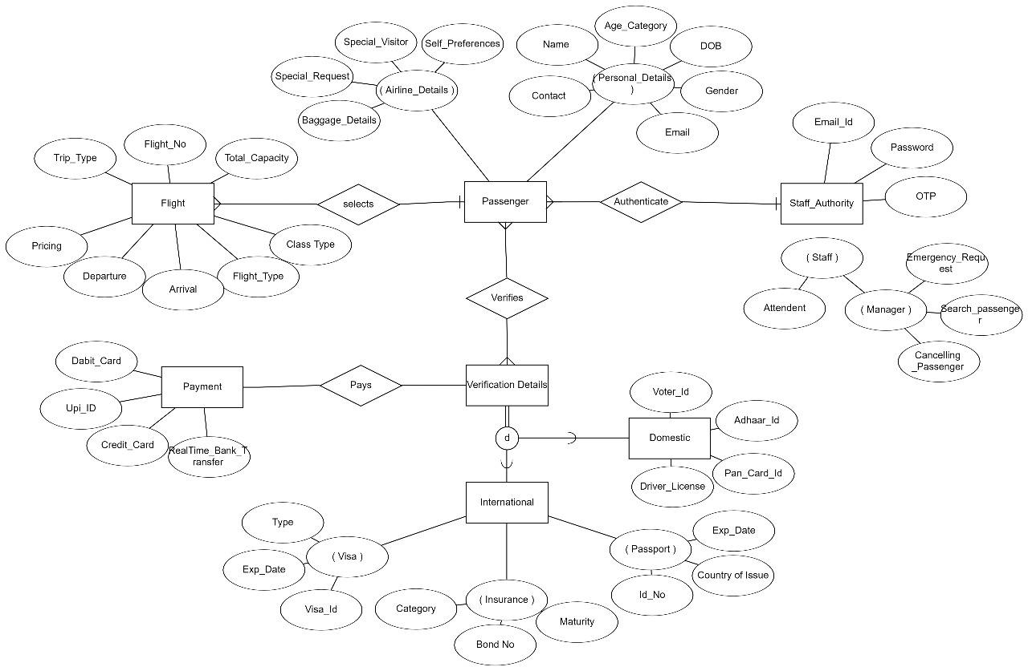
The Airline Reservation System provides history of all passengers with the flights timings and their ID details. The main purpose of this project is to reduce the manual work of ticket booking by online ticket booking of flights with short verification. This software is capable of managing Passenger details, Flight timing and Passenger Check-In authentication portal. The Airline Manager will act as the administrator to flight timings . The airline staff will have portal through which they access the online reservation of each passenger and verify of departure. The application mainly allows the Passengers to easily book domestic and international flights.

2.2 User Classes and Characteristics
The system provides different types of flight services based on the type of users [Member/Librarian]. The passenger can be either a child or adult or a senior citizen who will be accessing airline services.

The features that are available to the Passenger are:-
- Can book domestic and international flights..

- Can view the different categories of classes available in the flight

- Can view the list of flights available for each routes.

- Cancel the booked flight within specified period.

- Edit the information of existing ticket.

- Can check the status of booked ticket.

- Can postpone the booked ticket.

The features that are available to the Members are:-
- Can verify and book tickets online.

- Can timing of each flight.

- Can book both international and domestic flights.

- Can add baggage details in online ticket booking itself.

- Can special request for disability

- Can view the history of previous booking.

2.3 Operating Environment

This application will be operating in windows environment. The Airline Reservation System is a website and shall operate in all famous browsers, for a model we are taking Microsoft Internet Explorer, Google Chrome and Mozilla Firefox. The only requirement to use this online product would be the internet connection.

The hardware configuration include Hard Disk: 40 GB, Monitor: 15” Colour monitor, Keyboard: 122 keys. The basic input devices required are keyboard, mouse and output devices are monitor, etc.

2.4 Assumptions and Dependencies
The assumptions are:-
- The coding should be error free

- The system should be user-friendly so that it is easy to use for the users

- The information of all passengers, flights must be stored in a database that is accessible by the website

- The system should have more storage capacity and provide fast access to the database

- The system should provide search facility and support quick transactions

Internet connection

- Users must have their correct usernames and passwords to enter into their online accounts and do actions

The dependencies are:-
- The specific software due to which the application will be run

- On the basis of listing requirements and specification the project will be developed and run.

- The system should have the general report stored

- The information of all the users must be stored in a database that is accessible by airline staffs.

2.5 Requirement
Software Configuration:-

This software package is developed using java as front end which is supported by sun micro system. Microsoft SQL Server as the back end to store the database. Operating System: Windows NT, windows 98, Windows XP

Language: Java Runtime Environment, Net beans 7.0.1 (front end)
Database: MS SQL Server (back end)

Hardware Configuration:-
Processor: Pentium(R)Dual-core CPU
Hard Disk: 40GB
RAM: 256 GB or more

2.6 Data Requirement

The inputs consist of the query to the database and the output consists of the solutions for the query. The output also includes the user receiving the details of their accounts. In this project the inputs will be the queries as fired by the users like create an account, selecting flight and booking ticket. Now the output will be visible when the user requests the server to get details of their ticket in the form of time, date and which fight is currently in their account.

3. External Interface Requirement
3.1 GUI

The software provides good graphical interface for the Passenger and the agent can operate on the system, performing the required task such as create, update, viewing the details of the passengers.
    - It allows Passenger to view flight details, timings.
    - It provides Passport verification and search facility based on different criteria.
    - The user interface must be customizable by the agent
    - All the modules provided with the software must fit into this graphical user interface and accomplish to the standard defined
    - The design should be simple and all the different interfaces should follow a standard
template
    - The user interface should be able to interact with the user management module and a part of the interface must be dedicated to the login/logout module

Login Interface:-
In case the user is not yet registered, he can enter the details and register to create his account. Once his account is created he can ‘Login’ which asks the user to type his username and password. If the user entered either his username or password incorrectly then an error message appears.

Search:-
The passenger can enter the type of flight he is looking for and the title he is interested in, then he can search for the required flight by entering the flight name.

Categories View:-
Categories view shows the categories of flights available and provides ability to the agent to add/edit or delete category from the list.

Agent's Control Panel:-
This control panel will allow agent to add/remove users; add, edit, or remove a resource. And manage lending options.

4.System Features
The users of the system should be provided the surety that their account is secure. This is possible by providing:-
- User authentication and validation of members using their unique member ID
- Proper monitoring by the administrator which includes updating account status, showing a popup if the member attempts to book more than 1 flight that exceed the limit provided by the management .
- Proper accountability which includes not allowing a user to see other user’s account. Only administrator will see and manage all user’s accounts

Other Non-functional Requirements

Performance Requirement
The proposed system that we are going to develop will be used as the Chief performance system within the different campuses of the university which interacts with the agent and passengers. Therefore, it is expected that the database would perform functionally all the requirements that are specified by the university.
    - The performance of the system should be fast and accurate
    - Airline reservation System shall handle expected and non-expected errors in ways that prevent loss in information and long downtime period. Thus it 4hould have inbuilt error testing to identify invalid username/password
    - The system should be able to handle large amount of data. Thus it should accommodate high number of flights and users without any fault

5.2Safety Requirement

The database may get crashed at any certain time due to virus or operating system failure. Therefore, it is required to take the database backup so that the database is not lost. Proper UPS/inverter facility should be there in case of power supply failure.

5.3.Security Requirement
    - System will use secured database
    - Normal users can just read information but they cannot edit or modify anything except their personal and some other information.
    - System will have different types of users and every user has access constraints
    - Proper user authentication should be provided
    - No one should be able to hack users’ password
    - There should be separate accounts for admin and members such that no member can access the database and only admin has the rights to update the database.

Requirement attributes
    - There may be multiple admins creating the project, all of them will have the right to create changes to the system. But the members or other users cannot do changes
    - The project should be open source
    - The Quality of the database is maintained in such a way so that it can be very user friendly to all the users of the database
    - The user be able to easily download and install the system

Business Rules
A business rule is anything that captures and implements business policies and practices. A rule can enforce business policy, make a decision, or infer new data from existing data.This includes the rules and regulations that the System users should abide by. This includes the cost of the project and the discount offers provided. The users should avoid illegal rules and protocols. Neither admin nor member should cross the rules and regulations.

User Requirement
The users of the system are passengers and agent of the airline reservation management who act as administrator to maintain the system. The members are assumed to have basic knowledge of the computers and internet browsing. The administrators of the system should have more knowledge of the internals of the system and is able to rectify the small problems that may arise due to disk crashes, power failures and other catastrophes to maintain the system. The proper user interface, user manual, online help and the guide to install and maintain the system must be sufficient to educate the users on how to use the system without any problems.
The admin provides certain facilities to the users in the form of:-
    - Backup and Recovery
    - Forgot Password
    - Data migration i.e. whenever user registers for the first time then the data is stored in the server
    - Data replication i.e. if the data is lost in one branch, it is still stored with the server
    - Auto Recovery i.e. frequently auto saving the information
    - Maintaining files i.e. File Organization
    - The server must be maintained regularly and it has to be updated from time to time

6. Other Requirements
6.1 Data and Category Requirement

There are different categories of users namely Airline manager, Airline staff ,passenger etc. Depending upon the category of user the access rights are decided. It means if the user is an manager then he can be able to modify the flight departure timings, arrival timings etc. Manager has the rights to retrieve the information about database. Similarly there will be different categories of flight available. According to the categories of flight their relevant data should be displayed. The categories and the data related to each category allotted to respective pricing.

6.2 Appendix

A:Airline manager, Airline staff; C: Class, Client, Conventions; D: Data requirement, Dependencies; G: GUI; K: Key; N:Non-functionalRequirement;O:Operatingenvironment;P:
Performance, Perspective, Purpose; R: Requirement, Requirement attributes; S: Safety, Scope,
Security, System features; U: User, User class and characteristics, User requirement;;

6.3 Glossary

The following are the list of conventions and acronyms used in this document and the project as well:

- Administrator: A login id representing a user with user administration privileges to the software

- User: A general login id assigned to most users

- Client: Intended users for the software
➢ SQL: Structured Query Language; used to retrieve information from a database
- SQL Server: A server used to store data in an organized format

- Layer: Represents a section of the project

- User Interface Layer: The section of the assignment referring to what the user interacts with directly

- Application Logic Layer: The section of the assignment referring to the Web Server. This is where all computations are completed
- Data Storage Layer: The section of the assignment referring to where all data is recorded

- Use Case: A broad level diagram of the project showing a basic overview

- Class diagram: It is a type of static structure diagram that describes the structure of a system by showing the system’s cases, their attributes, and the relationships between the classes
- Interface: Something used to communicate across different mediums

- Unique Key: Used to differentiate entries in a database

6.4 Class Diagram

A class is an abstract, user-defined description of a type of data. It identifies the attributes of the data and the operations that can be performed on instances (i.e. objects) of the data. A class of data has a name, a set of attributes that describes its characteristics, and a set of operations that can be performed on the objects of that class. The classes’ structure and their relationships to each other frozen in time represent the static model. In this project there are certain main classes

which are related to other classes required for their working. There are different kinds of relationships between the classes as shown in the diagram like normal association, aggregation, d generalization. The relationships are depicted using a role name and multiplicities. Here ‘Librarian’, ‘Member’ and ‘Books’ are the most important classes which are related to other classes.

